Assignment 1: Version Control

Samuel R. Mortimer

For this version control project, it was decided that a platformer game base was going to be made, that could later be modified into a proper platformer.

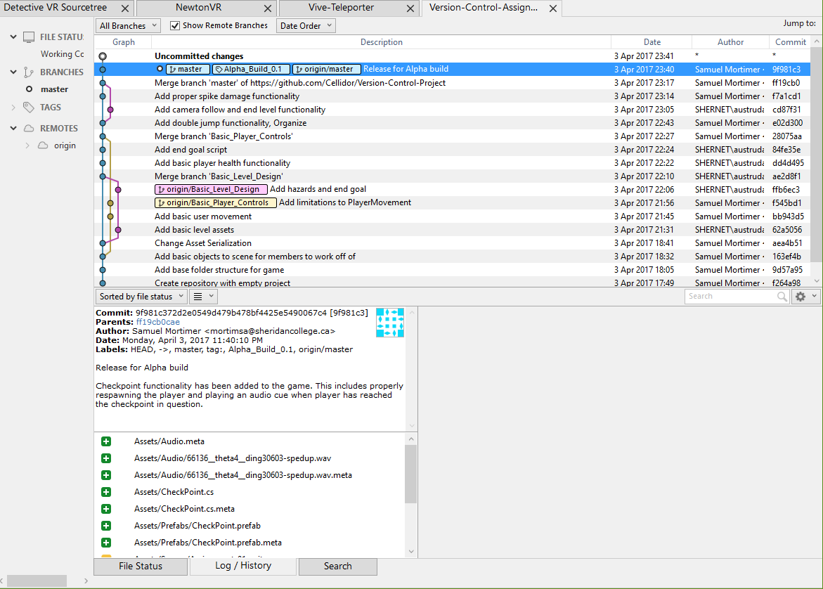

To achieve the requirements, a base scene would be required so the “Level Designer” and “coder” could both begin their work. This involved setting up a simplistic scene with building blocks for the level, a player prefab, and setting up proper folder structure.

Once this was achieved, two branching paths were created. One would handle the initial scripting, the other would handle level design. During this process, serialization had to be changed for the project. Once the movement scripts and level design were done, both were merged back into the master line (this clears requirements for 2-3 merges).

For the merge conflict, the script for “player health” was modified in two very different ways.

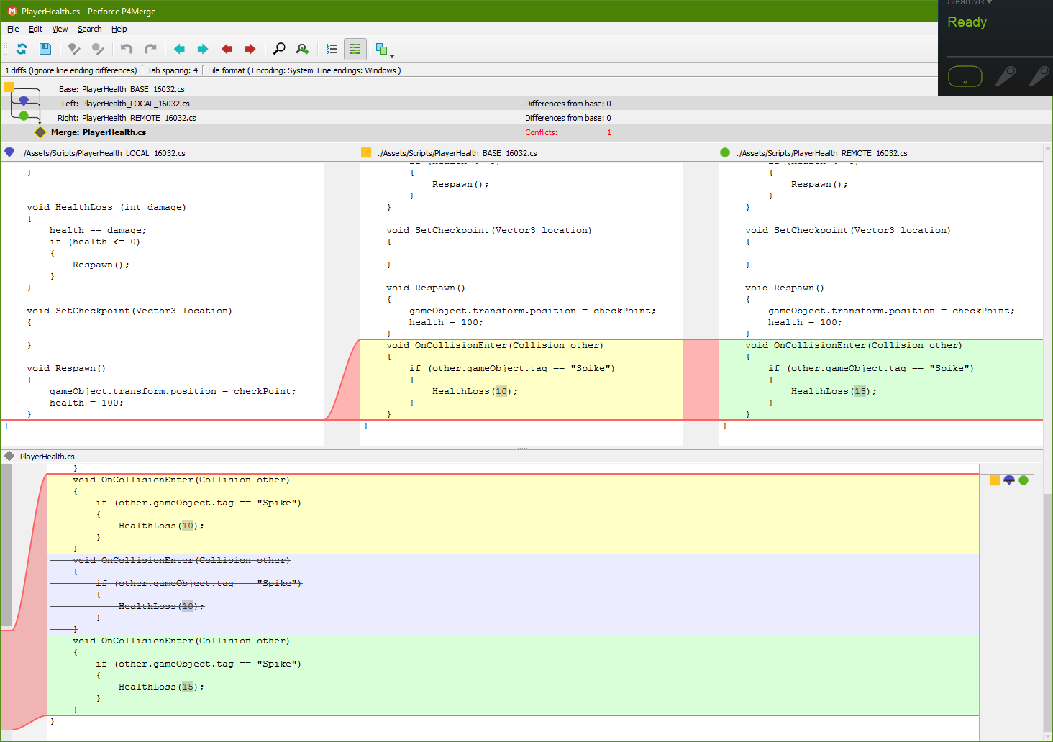

As can be seen, while one developer wished to change the damage spikes dealt to a higher value, the other had removed that portion of the script entirely to somewhere else. Given this instance, the script movement was changed, with the change in damage being applied to the location where the script segment ended up.

To reflect on the process, one particular technical irritancy regards how Sourcetree will not include empty folders. This makes the initial set-up of a proper folder structure difficult unless the one doing so places a “dummy” item in each created folder. What’s more, this can return as a problem two-fold later on as a deleted folder without a paired deleted meta-file will result in a folder returning over and over unless all users delete it at the same time before pushing.

Furthermore, it is worth noting that it’s always important to make sure each user understands the limitations that Sourctree on its own holds regarding Unity Scenes and Prefabs, given that even with P4Merge, it cannot handle these merges cleanly. The only real solution to this is to use specific merge tools for Unity, but even they aren’t guaranteed to work. Given this is the case, users should ensure they do not work on scenes or prefabs simultaneously.